OUTLINE:

General interests,

Code interests,

Ideal project attributes,

Project ideas (description and voting)

GENERAL INTERESTS:

Examples: <https://software.nasa.gov/>

<https://www.coderus.com/app-ideas/>

Lane’s general interests:

* Finance
* Data Translation / Storage / Processing
* Entertainment
* Cloud Computing
* Advanced Mathematics / Theoretical Computer Science

Quinton’s general interests:

* Advanced Math / Theoretical COSC
* Big Data
* AI
* Efficient algorithms
* Entertainment
* Functional Programming

CODE INTERESTS:

Lane’s code interests:

* Love: **C++**, Java, Python, LaTeX, LISP
* Neutral: C, Matlab
* Hate: **SQL (and similar)**, JavaScript, HTML/CSS, R, Haskell
* Learning:
* Don’t Know: Kotlin, Swift, Rust, TypeScript, C#

I want to do algorithms, software design, bulk code writing/testing

I don’t like front-end

Quinton’s code interests:

* Love: Javascript, Haskell, Python (sorta relearning)
* Neutral: R, Latex, LISP, C++, Matlab
* Hate: Java, HTML/CSS, Assembly
* Learning: Scala, C#
* Don’t Know: C (worked with very little), Kotlin, Swift, Rust, TypeScript, SQL, Go

I like more of the backend work on algorithms and designing the structure. I don’t love front-end development but I don’t mind it.

IDEAL PROJECT ATTRIBUTES:

Lane’s ideal project attributes:

Difficulty to create:

* medium (will certainly create a useable, working product by May 2023)

Difficulty to use:

* medium (no confusing UI, but not stupid easy)

Does family understand (could they use it)?

* Fuck no

Do friends understand (could they use it)?

* Smart friends

Do prospective employers understand (could they use it)?

* Of course, yes

Target user:

* Nerds, average to advanced (dummies won’t understand or use)

Download likelihood:

* Low (I don’t give a shit who uses it, I’m going to)

Resources required to create/use product:

* Advanced Research Computing Center supercomputer to run some machine learning
  + I’d be fine requiring limited laptop computing but I’d love to do something heavy
* no annoying login
  + Local database storage as file on device (no hosting platform: AWS, Azure)
* Free to use / download
* Android device to download / use app from Google play store

Do you want to capitalize on your project? (Do you or university own the code?)

* I don’t care if the university owns my code so it would be fine to use their equipment for development

Quinton’s ideal project attributes:

Difficulty to create:

* At least medium, I want it to be something that shows I’ve learned something but not so hard it’s going to kill me and hurt my other classes.

Difficulty to use:

* Mid, I need the UI to not piss me off, but over simplifying feels like it can hurt some things.

Does family understand (could they use it)?

* Maybe my brother, but not a chance I could get through explaining it to any of the rest.

Do friends understand (could they use it)?

* They might, some of them.

Do prospective employers understand (could they use it)?

* Yes, this feels like one of the more important points to make sure of.

Target user:

* Nerds who sometimes have fun by doing stuff like solving math problems in their free time, like me.

Download likelihood:

* Not a ton, but at least 1 download from me.

Resources required to create/use product:

* Probably Github/some sort of online repo.
* Computer and phone, presumably, to download and test on.
* Ideally all the software and everything used to create it is free.

Do you want to capitalize on your project? (Do you or university own the code?)

* I don’t care if the university owns the code for something like this, I’m not very business-y anyways, if it helps with the project to utilize their equipment I’m fine with it.

PROJECT IDEAS AND VOTING:

VOTE FOR PROJECT:

Lane: Stock price prediction tool

* Why it’s cool / needed / important:
  + help financial decision making
* Why it’s achievable:
  + many versions already exist, data is available
* Industry?
  + Finance
* Elevator pitch:
  + Disclaimer: Don’t invest your life savings
  + For funsies (speculative traders only)
  + Magical if it works and it makes you money
  + Wyoming has no capital gains taxes

rough outline of what would need to be done for stock prediction:

- An app that presents a list of stocks that should be sold or bought day to day (essentially no interaction, only info presentation)

- use data from google finances, robinhood, public figure stock trade actions like nancy pelosi, warren buffet for example to make decisions (use the advanced research computing center supercomputer to run machine learning on this info)

very easy project to create. easy for people to understand. high likelihood of download.

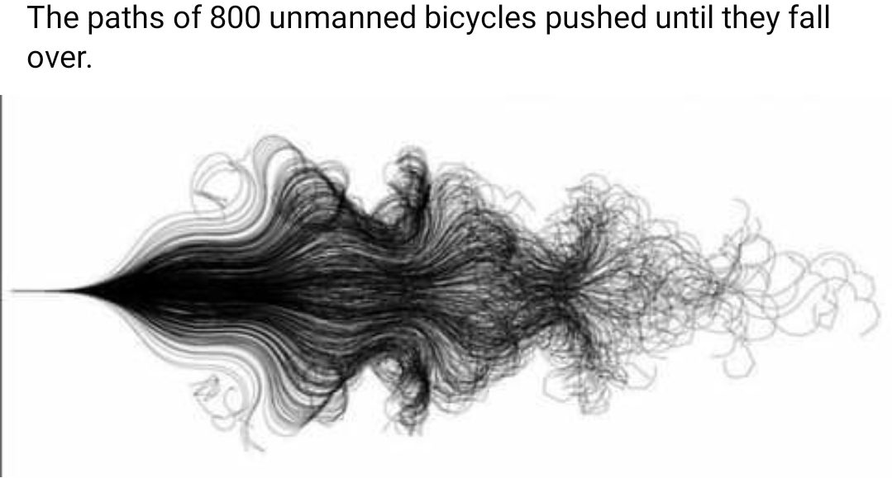

Idea based on this image: analysis of history of trades leading to better trades using machine learning

VOTE FOR PROJECT:

Lane: Automatic Music Generation from Image, Text translation tool

* Why it’s cool / needed / important:
  + fun, people need new instrumentals
* Why it’s achievable:
  + Easy af
* Industry?
  + Entertainment
* Elevator pitch:
  + Don’t want to create your own instrumentals? Let this tool create them automatically for you
  + Want to hear what your favorite book sounds like as a song?
  + Want to hear what your profile photo sounds like as a song?

Similar to [https://tones.wolfram.com/generate/](https://tones.wolfram.com/generate/G1N9U1vfC0a27heswGeIkgL7YbpgkTC5BSo2o3P4kDR6xt7h)

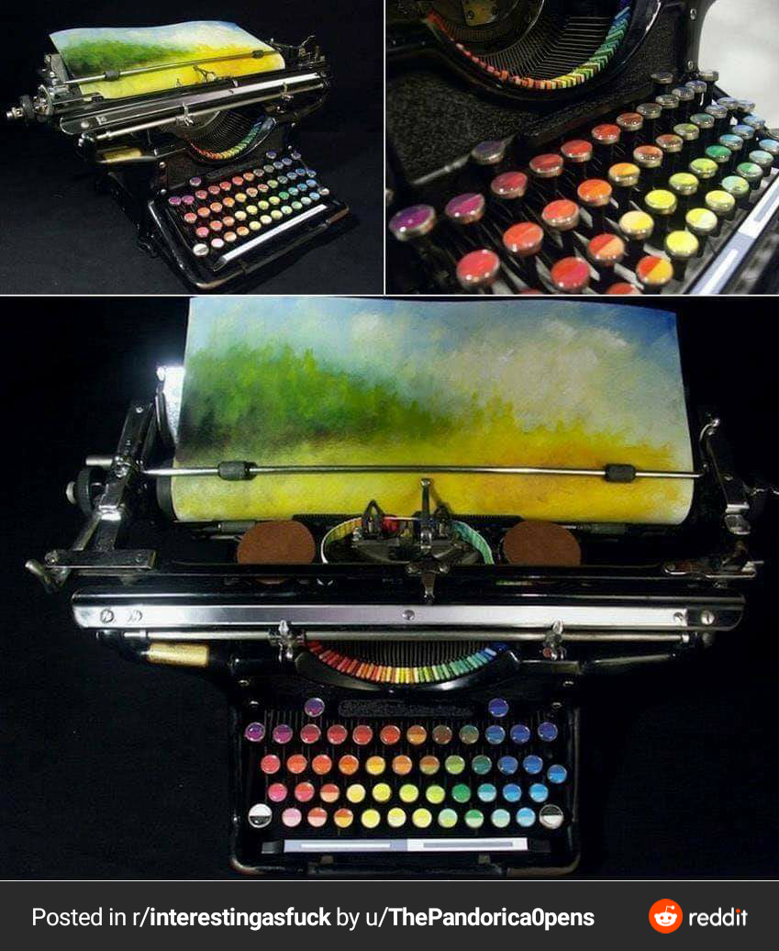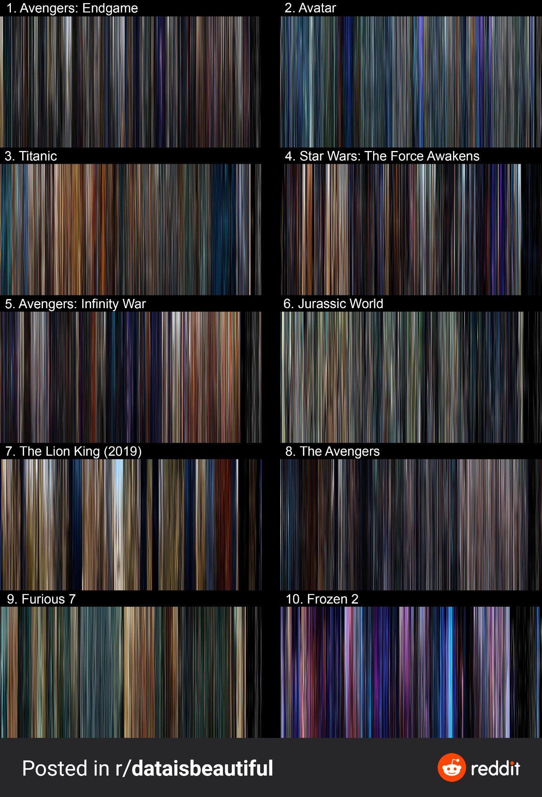

Idea based on these images: extracting / translating novel types of information from existing data

VOTE FOR PROJECT:

Lane: New Ways To Store Data

* Why it’s cool / needed / important:
  + Reducing information for minimal storage size
* Why it’s achievable:
  + Many compression algorithms exist that can inspire
* Industry?
  + Data storage
* Elevator pitch:
  + asdf

rough outline of what would need to be done for New Ways To Store Data:

- asdf

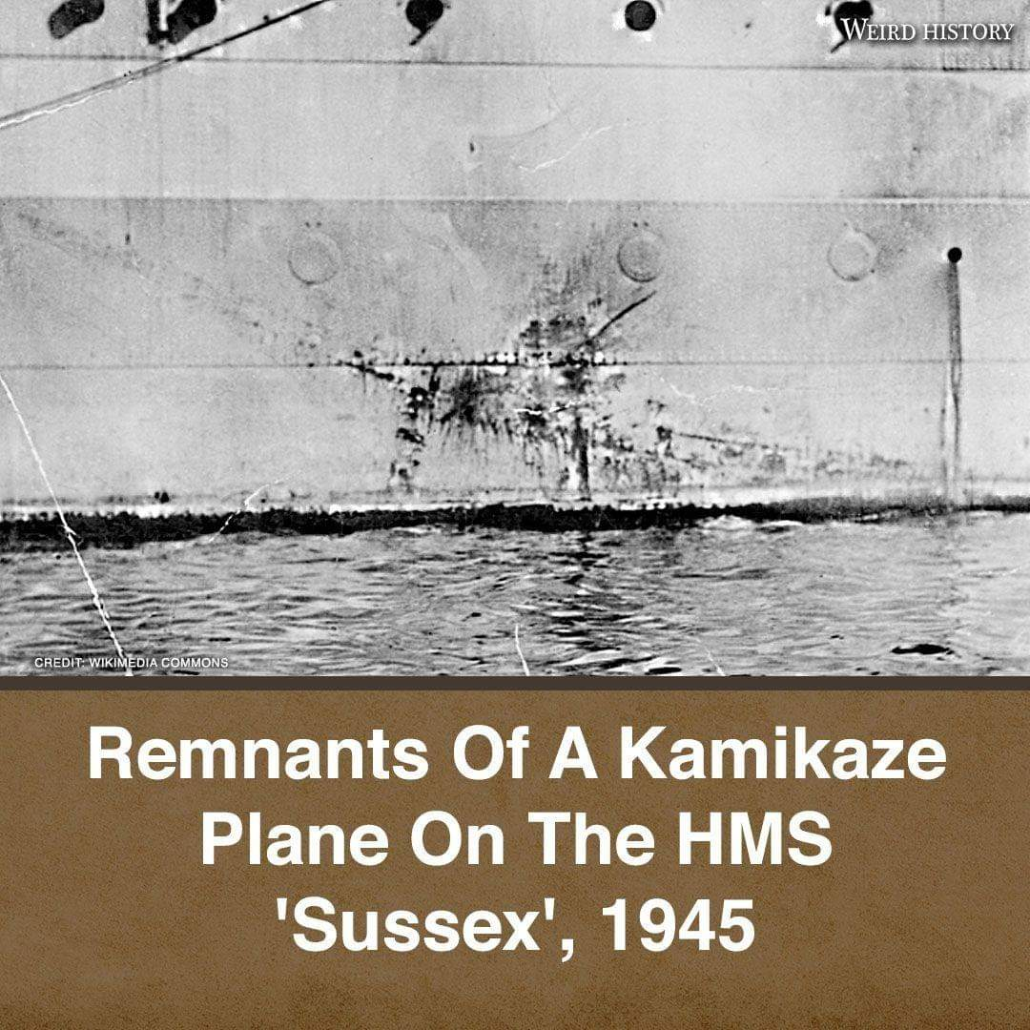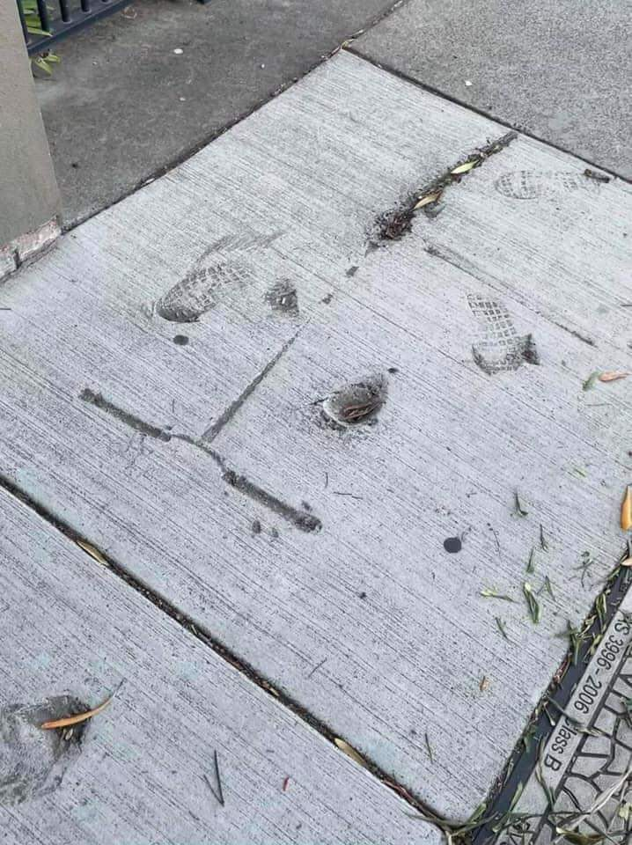

Idea based on these images: useful way to quickly and minimally store large amounts of relevant information

VOTE FOR PROJECT:

Quinton: Route checking/prediction app

* Why it’s cool / needed / important:
  + I’ve nearly crashed in the winter like a dozen times since starting college because my car sucks, it’d be nice to be able to have an app check out everything I want at once, instead of checking 5 different weather reports and considering the drive time and checking the WyDoT website several times on the drive.
* Why it’s achievable:
  + It’s not overly complicated and most of the information is already there but just not consolidated anywhere.
* Industry?
  + Transportation? Does that count as an industry?
* Elevator pitch:
  + You don’t even have to create or calculate much information at all, you just consolidate other info already out there.
  + Who doesn’t want to get paid for doing basically nothing? You just need the algorithms and to host it somewhere, it should be used by at least a fair amount of people without needing to market since there’s a gap in the market right there. Especially if it works between states/countries.

rough outline of what would need to be done for PROJECT TEMPLATE:

- Figure out the structure of the returned function calls from various websites, to code it together correctly.

- Probably should figure out how the law works, like can a tiny watermark and hyperlink just go in the corner and we’re fine?

- Create a UI for a website with a way of displaying all the information in an organized way that doesn’t require 5 minutes to figure out what you’re looking at.

- Need an algorithm to *reliably* predict the range of conditions a road could have, given the current conditions, weather report, and drive time there from your time of departure.

- Need a way to basically snatch google maps info, like the cities along a route you chose and how long it approx. takes to get to each, along with info from various DoT websites.

VOTE FOR PROJECT:

Lane: Store Password As Image

* Why it’s cool / needed / important:
  + New / secure way to secure password
* Why it’s achievable:
  + Easily map pixels to password / password to pixels
* Industry?
  + Security
* Elevator pitch:
  + asdf

rough outline of what would need to be done for PROJECT TEMPLATE:

- asdf

VOTE FOR PROJECT:

NAME: TEMPLATE FOR PROJECT IDEA

* Why it’s cool / needed / important:
  + asdf
* Why it’s achievable:
  + asdf
* Industry?
  + asdf
* Elevator pitch:
  + asdf

rough outline of what would need to be done for PROJECT TEMPLATE:

- asdf

VOTE FOR PROJECT:

NAME: TEMPLATE FOR PROJECT IDEA

* Why it’s cool / needed / important:
  + asdf
* Why it’s achievable:
  + asdf
* Industry?
  + asdf
* Elevator pitch:
  + asdf

rough outline of what would need to be done for PROJECT TEMPLATE:

- asdf

VOTE FOR PROJECT:

NAME: TEMPLATE FOR PROJECT IDEA

* Why it’s cool / needed / important:
  + asdf
* Why it’s achievable:
  + asdf
* Industry?
  + asdf
* Elevator pitch:
  + asdf

rough outline of what would need to be done for PROJECT TEMPLATE:

- asdf

VOTE FOR PROJECT:

NAME: TEMPLATE FOR PROJECT IDEA

* Why it’s cool / needed / important:
  + asdf
* Why it’s achievable:
  + asdf
* Industry?
  + asdf
* Elevator pitch:
  + asdf

rough outline of what would need to be done for PROJECT TEMPLATE:

- asdf

VOTE FOR PROJECT:

NAME: TEMPLATE FOR PROJECT IDEA

* Why it’s cool / needed / important:
  + asdf
* Why it’s achievable:
  + asdf
* Industry?
  + asdf
* Elevator pitch:
  + asdf

rough outline of what would need to be done for PROJECT TEMPLATE:

- asdf

VOTE FOR PROJECT:

NAME: TEMPLATE FOR PROJECT IDEA

* Why it’s cool / needed / important:
  + asdf
* Why it’s achievable:
  + asdf
* Industry?
  + asdf
* Elevator pitch:
  + asdf

rough outline of what would need to be done for PROJECT TEMPLATE:

- asdf

VOTE FOR PROJECT:

NAME: TEMPLATE FOR PROJECT IDEA

* Why it’s cool / needed / important:
  + asdf
* Why it’s achievable:
  + asdf
* Industry?
  + asdf
* Elevator pitch:
  + asdf

rough outline of what would need to be done for PROJECT TEMPLATE:

- asdf

VOTE FOR PROJECT:

NAME: TEMPLATE FOR PROJECT IDEA

* Why it’s cool / needed / important:
  + asdf
* Why it’s achievable:
  + asdf
* Industry?
  + asdf
* Elevator pitch:
  + asdf

rough outline of what would need to be done for PROJECT TEMPLATE:

- asdf